**Odoo x Gujarat Vidyapith Hackathon '25 - Idea Document**

**Team Name and Member Details**

* **Team Name:** Naruto Coders
* **Member Details:**
  + Milan Baladaniya (Team leader)
  + Yash Vaghasiya
  + Meet Vaghasiya

**1) Problem Statement**

**Bridging Natural Farmers and Conscious Consumers**

**Problem:**

Farmers practicing natural farming struggle to find reliable markets, while consumers cannot easily verify the authenticity of natural farming products.

**Problem Analysis:**

* Farmers lack digital access to a large consumer base.
* Middlemen reduce farmer profits and increase costs for consumers.
* Consumers have no reliable way to verify whether products are genuinely organic or natural.
* Farmers lack an efficient online bidding system to sell their produce at fair prices.

**Target Audience:**

* **Farmers** practicing natural and organic farming.
* **Health-conscious consumers** looking for verified natural products.
* **E-commerce businesses and retailers** focusing on sustainable produce.
* **Bulk buyers and businesses** needing a competitive marketplace for natural farm products.

**2) Solution Overview**

**Transparent Natural Farming Marketplace**

A **blockchain-powered, AI-enabled e-commerce platform** that connects **verified natural farmers** with consumers through digital certification, QR code-based product traceability, and AI-powered recommendations.

**Work Flow Diagram:**

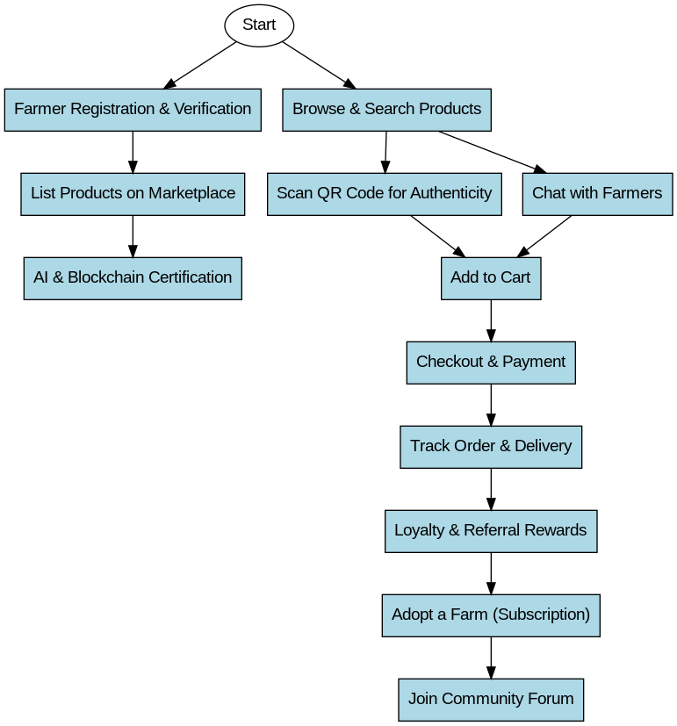

**Key Features:**

**Farmer Services**

* **Farmer Digital Verification System → Multi-step verification to ensure only genuine natural farmers are listed.**
* **Organic Product Certification → AI and blockchain-based verification to check product authenticity.**
* **Bid Tracking Dashboard** → **Farmers can track all bids and select the highest bid.**
* **Analytics Dashboard → Sales insights, demand trends, and customer feedback**.
* **Marketplace Access → Farmers can list products directly for buyers.**
* **Analytics Dashboard → Sales insights, demand trends, and customer feedback.**
* **Fair Pricing Algorithm → AI-driven system suggests fair pricing based on demand.**
* **Voice-Based Product Listing → Farmers can add products using voice commands in regional languages.**

**Consumer Features**

* **AI-Powered Crop Authenticity & Quality Scanner** → Consumers scan fruits, vegetables, or grains via phone camera to check quality and authenticity.
* **QR Code Scanner** → Scan product QR codes to verify authenticity, farm details, and sustainability impact.
* **Subscription Model** → Consumers can subscribe for weekly or monthly deliveries.
* **Direct Chat with Farmers** → Build trust through communication.
* **AI-Powered Personalized Health Recommendations** → Suggests natural farm products based on health goals (e.g., boosting immunity, reducing diabetes risk).
* **Virtual Farm Adoption** → Consumers can adopt a farm plot and receive monthly deliveries.
* **Live Bidding System** → Buyers can place bids on listed farm products in real-time auctions.
* **Instant Purchase Option** → Buyers can choose to buy at a fixed price if they don’t want to bid.

**Payment and Rewards**

* **UPI, Crypto, and Bank Payment** → Support multiple payment options.
* **Loyalty Rewards** → Gamify eco-friendly shopping with points redeemable for discounts.
* **Referral System** → Users get discounts for referring friends.
* **Farmer Subscription Model** → Premium features for farmers: promotion, analytics, and bulk selling.

**E-Commerce Features**

* **Categorized Listings** → Vegetables, fruits, dairy, organic fertilizers, etc.
* **Advanced Filters** → Search by location, product type, certification, and farm ratings.
* **AI-Powered Recommendations** → Personalized product suggestions.
* **Shopping Cart and Wishlist** → Save and track products.
* **Secure Checkout and Order Tracking** → Real-time tracking of deliveries.
* **Hyperlocal Delivery System** → AI-based route optimization.
* **Eco-Friendly Packaging** → Offer biodegradable packaging choices.

**Community and Education**

* **Farmer Blog and Tutorials** → Educate farmers about digital markets, certifications, and better pricing.
* **Consumer Awareness Campaigns** → Teach consumers about sustainable shopping.
* **AI Chatbot** → Guide users on product selection and queries.
* **Community Forums** → Discussion space for farmers and consumers.

**3) Frameworks and Technologies**

**Frontend (User Interface)**

* **React.js / Next.js** → Dynamic and responsive web application.
* **React Native** → Mobile app development (Android and iOS).
* **Tailwind CSS / Bootstrap** → UI styling and components.

**Backend (Server and Logic)**

* **Django / FastAPI** → User authentication, transactions, database management.
* **MongoDB**  → Database for farmer profiles, product details, and transactions.

**Blockchain (For Transparency and Trust)**

* **Ethereum / Polygon / TON Blockchain** → Smart contracts for product verification and payments.
* **IPFS (InterPlanetary File System)** → Decentralized storage for farmer certifications.

**QR Code Generation**

* **Python (qrcode library) / Google Charts API** → Generate QR codes linking to product verification.

**Cloud and Hosting**

* **Firebase**→ Cloud hosting, authentication (Google, Telegram, Email), and real-time data storage.
* **Vercel / Netlify** → Fast frontend deployment.

**4) Feasibility and Implementation**

**Implementation Ease**

* Modular architecture ensures easy development and scaling.
* Open-source tools and frameworks reduce costs.

**Effectiveness**

* Direct farmer-to-consumer connection ensures fair pricing and authenticity.
* Blockchain verification increases trust and eliminates fraud.
* AI-driven demand forecasting helps farmers plan crop production.

**5) UI/UX Mockup**

* **Screens Overview** → Wireframes showcasing marketplace UI.
* **User Flow** → Easy farmer registration, product listing, and consumer purchase journey.
* **Accessibility Considerations** → Voice navigation, multilingual support.

**6) Business Scope and Use Case**

* **Use Case Scenarios** → Case studies of farmers increasing sales through the platform.
* **Market Need** → Rising consumer demand for traceable organic food.
* **Revenue Model** → Commission-based earnings, premium subscriptions for farmers, and corporate tie-ups.

**7) System Design and Architecture**

* **Technologies Overview** → Key tools and services used.
* **Design Patterns** → MVC, microservices for scalability.
* **Functional Flow** → Flowcharts for user registration, purchasing, and verification processes.

**8) Coding Approach**

* **Development Strategy** → Agile methodology with sprint-based progress.
* **Coding Standards** → Code reviews, testing frameworks.

**9) Additional Supporting Documents**

* **Market Research** → Organic food industry statistics.
* **Competitor Analysis** → Comparison with existing platforms.
* **References** → Research links and studies.

This project will create a **fair, transparent, and sustainable ecosystem** for natural farmers and conscious consumers.